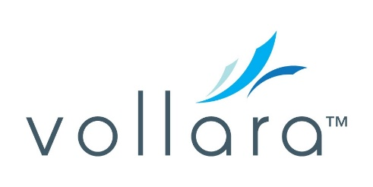

**2023 VOLLARA INCOME DISCLOSURE**(Last Updated July 10, 2024)

Vollara has prepared this income disclosure to give you information that may help you in your decision to become a Vollara business associate. Vollara has thousands of business associates in its system. Business associates may earn income through offering for sale Vollara products and services in accordance with Vollara’s Policies and Procedures and through commissions from their downline pursuant to the Company’s Compensation Plan. In 2023, approximately 3,000 business associates participated in our program and approximately 87% of those participating business associates signed up with Vollara simply to enjoy special product pricing and didn’t earn a commission. For 2023, the average income for those Vollara business associates that did receive a commission payment (“Active Business Associates”) was $1,742.08.[1] Less than 1% of Active Business Associates qualify for a Vollara incentive trip and the average earnings for incentive trip qualifying associates in 2023 was $166,053.00. The chart below gives further detail concerning Active Business Associates.

No purchase or training is necessary to become a Vollara business associate. Associates are required to pay annual dues in the amount of $30 for which they receive a product credit in the same amount to use on their next purchase. All products carry a 30-day money back guarantee.

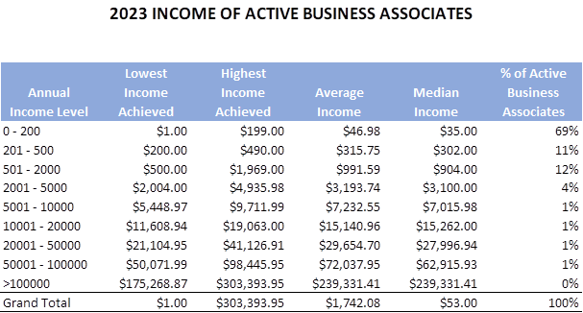

Note that your results will depend on a number of variables, including how much time you devote to the business, your skill and sales acumen, market conditions and business expenses you may incur. Vollara does not guarantee the earnings or trip eligibility of any distributors.

1. This amount includes non-cash payouts. This amount does not reflect the annual dues payment and corresponding credit.